Cellular Transport Processes

The plasma membrane is the barrier that separates the intracellular and extra cellular environments.
The main component of the plasma membrane is the lipid bilayer. Other structures making up the plasma membrane are cholesterol, carbohydrates and proteins.
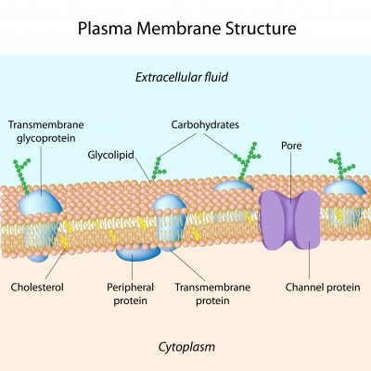

In order to survive and function properly, cells need to ______________________ substances across the _______________________ _____________________.
For example, __________________ is necessary for aerobic cellular _________________________ and must move into a cell from the blood.
Carbon dioxide ,a by-product of aerobic cellular respiration must move from inside the cell to the __________________________.

Oxygen and carbon dioxide move into/out of a cell by simple _________________________. This defined as the movement of a gas/liquid from an area of __________________ _____________________________ to an area of ________________________ ______________________________. Diffusion is a ______________________ form of transport meaning it does not require energy, and relies on a c________________________ g_____________________________ on either side of the _______________________ membrane.

Oxygen and carbon dioxide are able to cross the plasma membrane in this way because…

Add symbols and text to the image below to create a diagram that represents diffusion.

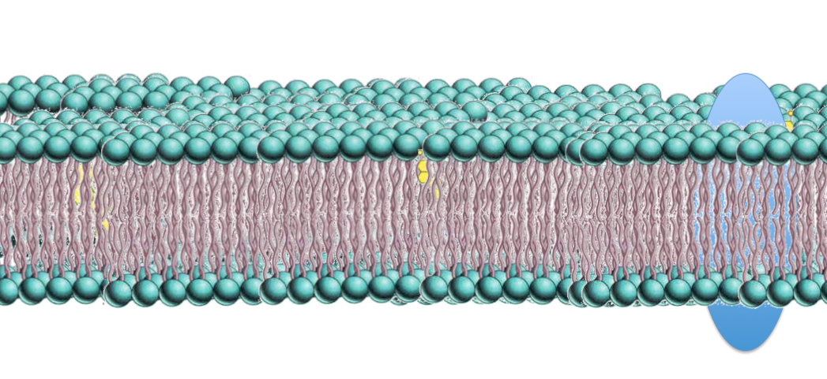

Some substances required by the cell cannot pass through the plasma membrane by simple diffusion, but their movement into or out of a cell is still driven by a c__________________________ g________________________.
For example, glucose, which is required for ___________________________ respiration cannot simply diffuse into a cell because it is to ______________________.
In order to move glucose into a cell, an integral t___________________ protein which is embedded in the plasma membrane acts as a tunnel/gate to allow glucose in. Glucose can move into a cell by travelling through these p________________ channels. This type of transport is called ___________________________ diffusion, as the protein facilitates or guides the glucose into or out of a cell. Because this does not require energy, and glucose still moves down it’s concentration ____________________________, this is a ______________________ process.

Glucose is not able to easily cross the plasma membrane because…

Add symbols and text to the image below to create a diagram that represents facilitated diffusion

Water is essential for all life and cells need a mechanism to absorb water. A special kind of diffusion called o_______________________, is a process that drives the movement of water. The movement of water is determined by the _________________________ gradient of solutes on either side of a membrane (the difference between the inside and outside of a cell).

O______________________ is the movement of water from an area of ___________ solute concentration to an area of ______________ solute concentration across a _________________ _______________________ ___________________.

If the extracellular environment in which a cell is in has a higher solute concentration than the int_________________________ environment, we say the cell is in a h___________________________ environment. Water will leave the cell. The cell will lose m_______________, perhaps lose s___________________ and in the case of a plant cell it may p_________________________. Plasmolysis occurs when a plant cell membrane detaches from the cell wall and the interior of the cell collapses. This occurs as _________________ is integral in maintaining the shape of a cell. Plants lacking water are seen to be fl__________________.

If the ex_______________________ environment in which a cell is in has a lower s______________________ concentration than the intracellular environment, we say the cell is in a h__________________________ environment. Water will enter the cell. The cell will gain _____________________. If too much water enters, a cell may lyse, which means to b__________________. When plant cells absorb water they become t________________.

When the solute concentration of the e_____________________________ environment is equal to the intracellular solute concentration, the environment is said to be __________________________. In this case, there will be movement of water in and out of the cell, but no overall net m_____________________________.
For every water molecule that exits the cell, one will e________________ the cell.

Water is able to cross the plasma membrane because…

Add symbols and text to the images below to create diagrams that represents osmosis

Active Transport

Often cells need to expend energy to move substances across the plasma membrane. Active transport is the term used to describe the movement of substances across the plasma membrane using energy (in the form of ATP, as opposed to passive transport which does not require energy). Cells often use active transport to move substance up a concentration gradient. That is, moving substances from an area of low concentration to an area of high concentration.

Types of active transport.

- The protein pump (e.g: the Sodium – Potassium pump)
- Endocytosis
- Exocytosis

For each of the types of active transport, write a definition, explanation of how it functions and a short list of the types of substances that are transported in this way.

