Cell Structure

Visit : http://sepuplhs.org/high/sgi/teachers/cell_sim.html and http://www.sheppardsoftware.com/health/anatomy/cell/index.htm to help complete the tasks below.

When drawing cell diagrams, use the following key structures as appropriate. Not all of the structures will apply to all of the cells.

Key terms
Cell membrane (plasma membrane), Genetic material, Cytoplasm, Cell wall, Large vacuole, Small vacuole Ribosome, Chloroplast, Flagella, Pilli, Mitochondria, Rough Endoplasmic Reticulum, Smooth Endoplasmic Reticulum, Capsule, Golgi Body (Golgi Apparatus), Lysosome, Nucleus

- Label the diagram of a typical bacterial cell.

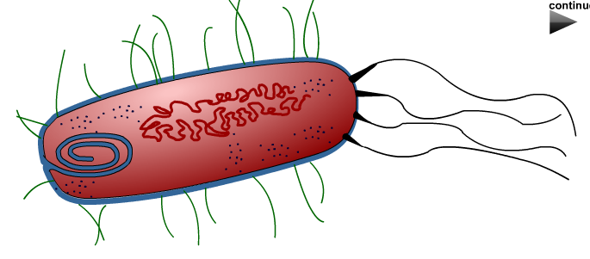

- Label the diagram of a typical plant cell.

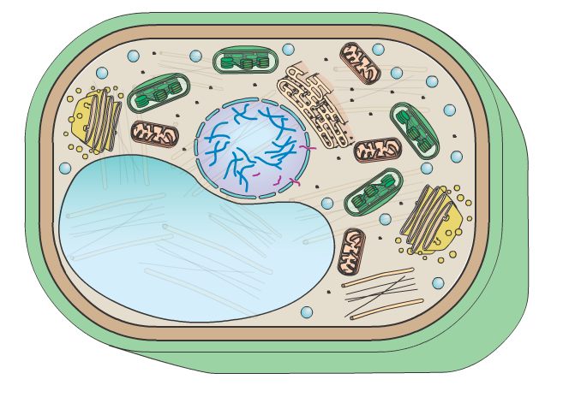

- Label the diagram of a typical animal cell.

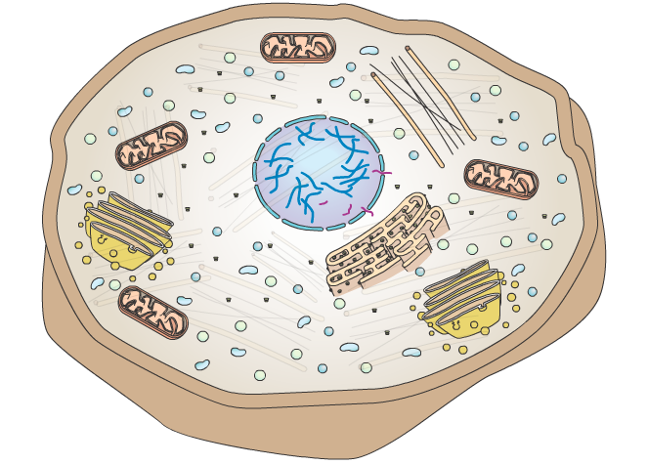

4) Compare and Contrast the animal and Plant cells – In animal cell to the left, list the organelles that are unique to animal cells. In the plant cell to the right, list the organelles that are unique to plant cells. Place the organelles that are found in both plant and animal cells in the area where the 2 cells below overlap (shared)
